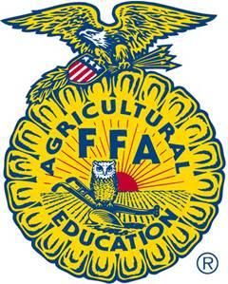
For Onslow office use only
Paid:_____ Date received:___________
Coastal Plains Chicken Project
Show: April 27, 2021
Lenoir County Livestock Arena
Registration Deadline: January 13, 2021

Name:

Name 4-H’er: _________________________________________________________________

FFA Organization ___________________________ EC Class ___________________________
FFA/EC classes will be asked to provide a list of student names & ages (as of Jan 1, 2021) by the chick pick-up date

Address: _____________________________________________________________________

Parent/Advisor Name: Phone: _______________________

Contact Email: _______________________________ County of participation: _______________

Date of Birth of 4-H’er: _____________________ Age as of January 1, 2021: _______________
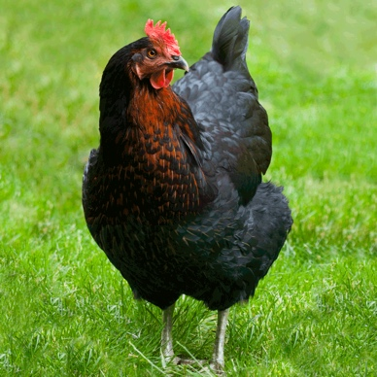
Choose option below:
Each bird costs $5. Must order a minimum of 2 birds of the
same breed. FFA chapters please include total number of birds.

Quantity | Breed
# | Broiler
# | Black Star Sex-Link

Wing bands will not be tagged on young biddies. If you are interested in applying identifiers in the future, leg bands are suggested. See your local livestock agent for help.

Please check the boxes below:
- I/We have read and understand all rules and regulations for the Regional Chicken Project and submitted the registration fee.
- I will complete a provided Poultry Project book by April 16, 2021.
- I will be responsible for all of my son/daughter’s expenses in meeting the requirements of the Regional Chicken Project.
- I will attend an orientation and showmanship training. (Only required for first time participants)

Youth signature: __________________________________ Date: _____________

Parent signature: __________________________________ Date: _____________

Make checks payable to NCCE-Onslow with “Chicken Project” on the memo line.
Return form and check to the Pender County Extension Office by January 13, 2021.
Regional Chicken Project Rules

- Youth ages 5-18, as of January 1, 2021, may participate in the program. They must be a 4-H member, a student who is taking an agriculture education class, or an FFA member of a participating school. Youth can enroll in their county 4-H program to participate.

- All first time participants of the Coastal Plains Chicken Project must attend an orientation training and a showmanship/project book training hosted by Cooperative Extension or a High School Ag Ed Program. These meetings will be held in multiple locations. Along with general information about raising birds, participants will be expected to follow the National 4-H Poultry Standard for showmanship, which will be covered at these meetings.

- Bring all purchased broilers to the show (including birds who you do not exhibit). Broilers are meat birds and are bred to live a short period of time. Keeping the bird for home use is an animal welfare issue. The Coastal Plains Show committee will process the birds and the meat will be donated to local food banks.

- Families and agricultural education classes can split birds, but every child must have their own bird they are responsible for.

- Participants will raise the chicks until the show, under the supervision of the guardians or agricultural education class, with help from Extension Agents and Teachers.

- The project will be canceled if the ban of showing chickens is in effect, due to the threat of Avian Influenza or other communicable diseases.

- Youth must choose to show either a broiler or a hen to exhibit at the show (however, you may use a different bird for showmanship) on Tuesday, April 27 ,2021 at the Lenoir County Livestock Arena in Kinston, NC. A qualified adult will judge the show. A NC Department of Agriculture Poultry Inspector will inspect/test the birds for parasites/disease.

- If you have a disaster (loss of multiple birds), you must contact your local county Extension Agent or Agricultural Education Teacher immediately (within 24 hours) so they may verify the situation and/or provide photographic evidence.

- Poultry Record Books must be completed and turned-in by 5:00pm on April 16, 2021 to your Extension Agent or FFA Advisor. Youth who do not turn-in books by the deadline will not be eligible for premiums/prizes.

- There will not be an auction, hens are the responsibility of the youth after the show. Broilers must be returned to show committee (see #3).

- All decisions by the judge are final. Direct criticism or interference with the judge, show or livestock show management, other exhibitors, breed representatives, or show officials before, during, or after the competitive event is prohibited. In the furtherance of their official duty, all judges, show, and livestock show management, or other show officials shall be treated with courtesy, cooperation and respect and no person shall direct abusive or threatening conduct toward them. Potential disqualification from future events after review is possible.

- Anticipated bird arrival date is the beginning of February for laying hen chicks and the beginning of March for broilers.

- Masks MUST be worn at the chicken show.

- Any special considerations not covered in the rules will be decided by the Regional Chicken Project Committee.

SHOWMANSHIP:
AGES 5-7: all receive a prize.
JUNIOR: Ages 8-10: 1st-5th places receive ribbon and 1st- $25, 2nd- $20, 3rd- $15, 4th-$10 and 5th- $5. All others receive a ribbon.
INTERMEDIATE- ages 11-13: 1st-5th places receive ribbon and 1st- $25, 2nd- $20, 3rd- $15, 4th-$10 and 5th- $5. All others receive a ribbon.
SENIOR- ages 14-18: 1st-5th places receive ribbon and 1st- $25, 2nd- $20, 3rd- $15, 4th-$10 and 5th- $5. All others receive a ribbon.

RECORD BOOKS:
Ages 5-7: all receive a ribbon
4-H Division 8-10, 11-13, 14-18: 1st- $15, 2nd- $10, 3rd, $5
FFA/ Ag Ed Division: 6-8 grade, 9-12 grade: 1st- $15, 2nd- $10, 3rd, $5
Breed Show (Black Star Sex-Link & Broiler Class):
Ages 5-18: Participation ribbon
Grand Champion (1st) per breed: $25
Reserve Champion (2nd) per breed: $20

Important Dates

January 13, 2021 – Registration & money due
Beginning of February 2021 – PROJECTED chick pick-up for laying hens
Beginning of March 2021 – PROJECTED Broiler pick-up
April 16, 2021 - Project Books Due

Show Day, April 27, 2021
Check-in: 3:00-4:30
Show Time: 5:00

County Extension Agent Contacts
Carteret County - Coleman Becton 252-222-6375

Craven, Jones, and Pamlico Counties - Katie Carter 252-876-5606

Duplin - Charmae Kendall 910-296-2143

Greene and Lenoir Counties - Eve Honeycutt 252-521-1706

Johnston - Dan Wells 919-989-5380

Onslow - Melissa Huffman 910-455-5873

Pender - Liz Peterson 910-259-1235

Pitt - Andy Burlingham 252-902-1703

Wayne - Stefani Sykes 919-731-1525

