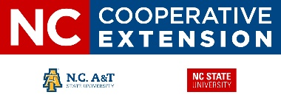

**County Trade Pull Factors & Industry Revenue (FY 18-19)**

**North Carolina – South Central District**



* **County Trade Pull Factor**

Measures the strength of the retail sector in a county

CTPF > 1.0 = pos. revenue

CTPF < 1.0 = neg. revenue

* **Trade Area Capture –**

Measures the equivalent spending capacity of a county relative to its permanent population

TAC = POP * CTPF

* **Market Share –** reflects the county’s portion of NC total retail spending.

MS = TAC ÷ POPState

* **Industry Revenue –**

Tourism/Travel - $8.924 B

Agriculture - $2.225 B

Forestry - $161.0 M

**Mark Seitz**

County Extension Director

April 2020

* Mecklenburg County has the largest economy. With a CTPF of 1.52 it generates 16.4% of the state’s revenue.
* Charlotte business attracts employees from at least 32 surrounding counties.
* The South Central District generates $11.6 billion in annual sales tax revenue.
* Agriculture and forestry is the #1 industry in 11 of 20 counties, generating $2.38 billion in annual revenue.
* Union County has the 4th largest agriculture industry in NC
* Cumberland County hosts Fort Bragg and Pope AFB

**NC Cooperative Extension – Pender County**

801 S. Walker Street

Burgaw, NC 28425

910-259-1235