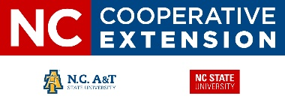

**County Trade Pull Factors & Industry Revenue (FY 18-19)**

**North Carolina – North Central District**

* **County Trade Pull Factor**

Measures the strength of the retail sector in a county

CTPF > 1.0 = pos. revenue

CTPF < 1.0 = neg. revenue

* **Trade Area Capture –**

Measures the equivalent spending capacity of a county relative to its permanent population

TAC = POP * CTPF

* **Market Share –** reflects the county’s portion of NC total retail spending.

MS = TAC ÷ POPState

Figure . Erosion control and water quality education in Wake County.

* Alamance, Durham, Forsyth and Guilford dominate the district’s economy with 16.2% of NC’s economy.
* Access to I-40, I-85 and I-77 generate $4.07 billion in tourism and travel revenue
* Agriculture and forestry is the #1 industry in only 4 of 20 NE District counties, generating $1.647 billion annually.

**NC Cooperative Extension – Pender County**

801 S. Walker Street

Burgaw, NC 28425

910-259-1235

**Mark Seitz**

County Extension Director

April 2020